A Case Study of a Covid-19 Cluster Using

the CovidSIMVL Simulation Model Tool

January 12, 2021

INTRODUCTION

At BlueBell Childcare in an urban area, with 5 staff and approximately 15 children from age 3 to 9, a staff member tested positive on Dec 24, and as usual, the information below is sketchy and incomplete. However, they form the constraints for the simulation modelling of a local cluster with specific dynamics, which leads to the question of how this might affect the family members of the staff and students, and any connection that they might have to the associated workplaces, especially if they are Long Term Care, or an Emergency Department.

The Data Constraints

This is what was collected:

Dec 18 Worker A and worked E work together.  
  
Dec 21 Worker A works at childcare centre (Cloverdale childcare).  Overlap with 2 other staff ( B, C)  
  
Dec 22, 23 Workers B and C overlap with worker D  
  
Dec 24 Worker A gets symptoms  
  
Dec 27 Worker A receives positive test result  
  
Jan 3 Daycare tells all workers to get tested as they were contacted by Island Health.  
  
Jan 3 or 4? Daycare informs families of exposure event and closes for the week.  Recommendation from Island Health to test all 3-5 year olds.  All other children watched for symptoms.  
  
Jan 5- worker E tests negative  
  
Jan 5- we know 5 children test positive but all were asymptomatic, all under 5 years old  
  
Community spread event: Sometime after Jan 3, One of the workers got her family tested and 3 more adults and 4 children in family all test positive.  (I don't know if this is a single household family, or if 'cousins' got together or if this is a blended family of 2 households?)  
  
Alf just reported, as of January 8 there are 16 known cases.

The Goals of this Inquiry

CovidSIMVL is an agent-based simulation model which can be considered a sandbox in which parameters and populations can be readily modeled to study behaviors and interactions. It is not intended to be a predictive model for IRL (“In Real Life”) situations, but this cluster provided an opportunity to back-fit the parameters to the data, and to then look forward to examine the implications for within-family transmission, and transference of Covid to other spaces. The viral temporal dynamics model of Xi is built into the CovidSIMVL program.

Without loss of generality, and without attempting to find more about the BlueBell Childcare IRL situation, we will proceed to make assumptions in constructing the simulation model in order to understand its dynamics.

METHODOLOGY

We create a population of staff, children and their families, with a daily schedule, which we follow slavishly in the simulation, without regard to weekends or holidays. When the staff and children are not in the Universe 0 (BlueBall ChildCare), we send them to the HOME Universe (U8), in which transmissions occur not just based on touch, but only if the potential transmission would be between family members.

We create three additional Universes – Long Term Care (Universe 1), Emergency Department (Universe 2), and a Community (Universe 7).

The simplifying relationships are as follows:

When students, staff and family members are not in other places, they are at HOME (with intra-family transmission at all times possible).

Students and staff only go to BlueBell Childcare or HOME. Their family members also always stay HOME, except for 4 individuals who are visitors (2) and staff at Long Term Care (2). Their hours are 2 hrs from 9 to 11am for visitors, and 8 for staff from 7am to 3pm.

There are also six persons who go to ED daily – 3 volunteers who go for 4 hours, and 3 health care workers who work 10 hrs a day.

The Long Term Care facility is populated by 50 residents who do not go away from it.

The Emergency Department has a different set of 50 patients designated to the facility in seven different days. These days were set by trial and error to capture a staff or volunteer who might have become a transmitter from the BlueBell-family nexus.

The following describe the schedule of movement between HOME and the BlueBell Childcare for these persons.





The other persons are placed into their Universes (LTC = Universe 1) and

Emergency Department = Universe 2 at initialization for LTC, and at the designated times for each group of 50 unique individuals.

The fundamental approach in the agent-based CovidSIMVL is to follow the temporal dynamics of the SARS-2-Cov infection as described by Xi,He [Nature Medicine Aug 2020] for persons of certain sizes and mobility within a fixed arena, each generation producing a new viral load, state, and position. Transmission occur based on the temporal dynamics rules, and persons move from one Universe to another according to schedules defined for each member of the population.

We have run many trials to establish parameters that produce dynamics of the simulated epidemic consistent with the data constraints, which are:

Dec 24 as T0 index case is symptomatic

Dec 27 T3 receives positive test result

Jan 5 T12 5 children test positive

Jan 3 – Jan 8 T11-T16 3 adults, 4 children who are family members test positive

Jan 8 T16 16 known cases in this cluster

Using the console.log function, CovidSIMVL records each transmission in terms of who was infected by whom, at what generation (Gen24 = Day 1), and in what Universe this took place. Thus, we can back fit parameter so the data above, although not exactly and not deterministically, since CovidSIMVL is highly stochastic.

We will follow one trial in some detail, and then give the results for a total of five repeated runs using parameters in the same envelope. Here is the initial setup, from the console.log.



In explanation, each of the Universes in CovidSIMVL (up to 9 can be used) can have its own setting for Mingle Factor (“mF”) and for an Inflation Index. The first controls the stochastic locality of a proposed move for an agent that is in a specific Universe, and the second is multiplies the current size of an agent (its Hazard Radius “HzR”) by that factor, so that we can compensate for the sparseness of a small number of agents within the standard arena of 800x600 pixels in a Universe.

These settings then produce specific dynamics for the agents that populate a Universe according to the schedules encompassed in the Population file which is a .csv format file that is read at initialization. The corresponding Case file used in all the trials contains a single agent (#0) which has been given an infection day of -4.2, so that it enters the system as a transmitting and symptomatic agent.

We will examine the impact of this synthetic Covid-19 cluster on:

1. The BlueBell ChildCare staff and children
2. The family members of the above
3. The LTC permanent residents
4. The Emergency Department (ED) pool
5. The overall interacting set of spaces (“the multiverse”)

The fundamental analysis tool is the console.log. This precise trace of the unfolding of the synthetic epidemics, following the dynamics conforming to the data constraints, gives the ability to visualize quantitatively the effect of the epidemic as it might progress in time. This is different from the compartment-based SEIR equation models, and is more like scenario projections.

**RESULTS**

We do the analysis in detail for one exemplar trial, then give summary results for a total of 5 trials using the same parameters that generated the exemplar. Here are infections to generation 400 (Day 16 Hr 16).



Notice that by this point, an infection in Universe 2 (ED) and one in Universe 7 (Community bin) has taken place. We will refer to this subsequently.

***Fit to Data Constraints***



There is some latitude as to whether “by Jan 8” includes Jan 8th or just to the end of Jan 7th. Therefore the fit to BlueBell + family constraint (16 by Jan 8th , of which 7 are family members, of which 4 are children) is reasonable.

The data constraint of 5 children infected by Jan 2 is exceeded by the number observed which is 7. Due to the stochastic nature of contacts after each move, another trial could have more staff members.

***Evolution of this Cluster to BlueBell Staff and Children***

This might be restated: at what point do all staff get infected, and do all the children get infected while at BlueBell, and do some of them get infected from secondary transmission chains that end up with their being infected in U8 by a family member?

First, we map the family structure for completeness. Second, we scan the console.log for any of the BlueBell staff and children being infected in U8.

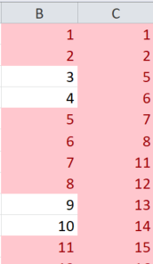Using Excel’s built-in function

for finding duplicate numbers in

two columns through Conditional Formatting, a subset shown on the

right, where C is the complete list

and B the list of infected agents

sorted after processing the console

log. Total uninfected was 18.

The result is the BlueBell Staff, children

and family infections on the right, where the yellow

entries mark the persons who were not infected at the

time the trial was terminated (later on this).

We see that two staff members (3,4) were not infected,

and only one of the staff family members was (21).

Two of the BlueBell children remained not infected at termination (9,10), while a number of children’s families were not infected. The block of BB children and family for (9,10) look unusual, and we will have

to see if other trials reproduce this kind of sequence.

From console.log, the last infection among BlueBell (0 to 19) was at gen 683, for person 15, a BlueBell child. This corresponds to approximately Day 28. The last infection for a family member (to agent 69) was at gen 972 for agent 55 (by agent 56). This is roughly 40.5 days from T0.

So the % of BlueBell group infected is 16/20 = 80%.

The % of BlueBell and family infected is 52/70 = 74.3%

**Did all BlueBell cohort get infected within BlueBell or Family?**

This question arises because 4 BlueBell family members go to LTC as visitors or staff and 6 go to ED as volunteers or health care workers. They may have infected one another there, whereas in U8 they can only infect if they are within the same family (and these are not).

Indeed, we have one entry for Universe 1 (LTC) and four for Universe 2 (ED). We reproduce these two entries:



and indeed, agent 32 and agent 32 are two agents we schedule to LTC:



The format for the population schedule (.csv) file is described elsewhere. However, reading from left to right, top line: “Agent 30, ticket stub 0, at 0 hrs is at universe 8, and at 7 hrs departs for Universe 1, where the role is that of Attendant, with a MingleFactor of 3, having an age of 30, and belonging to Family F06.”

Collecting the Universe 2 infections for agents <70 (BlueBell cohort and families), we get these entries:



These infections are from co-workers (50,54) so that for the total infections of the BlueBell cohort and family (62 in total), there were 5 that were outside of BlueBell or home. This constitutes 8% of infections.

Summarizing this part, the dynamics of the reported cluster at BlueBell are such that 88.9% of the BlueBell staff, children and their families are infected within 40.5 days from the first reported symptom on Dec 24, with only 8% of these infections taking place among these family members at common work places.

Furthermore, from the console.log, only 15 of all infections took place within U0 (BlueBell), while 31 took place in Universe8 (HOME). As we saw above, 5 occurred in other sites, while one was the index case, making 62 in total. The 15 infections represent 15/20 or 75% rate within the BlueBell location.

***The Long Term Care Permanent Residents***

By the time we terminated this trial, which is at T=1279 generations, all permanent residents in LTC (U1) have been infected, and are past their infectious period (13.2 days following date of infection). This is seen in the screen capture at termination.

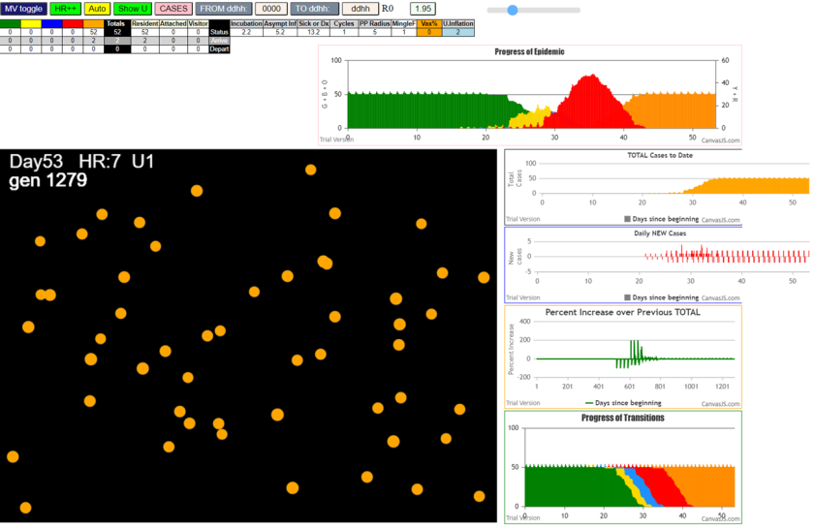

Orange is the color of agents in the inert post-infective state. This image has a lot of information, but we only need to look at two things here. The first is that all we see are orange agents. The second is the bar chart that has the red hump. The X-axis here reads 10 for the start of yellow, and just less than 30 for reds, and just after 40 for the end of the reds. The height at each day is the number of agents of that state, where

yellow = incubating,

red=symptomatic transmitters,

orange=inert and

blue=pre-symptomatic transmitters

Referencing this to the console.log, here are the first and last U1 infections:





The 487 and 734 gen times translate roughly to 20.3 and 30.6 days, which means that in 10 days, the entire 50 persons in LTC became infected. Even more interesting is that, with the parameter settings of U1 of inflation index of 2, the 50 infections were through 8 symptomatics (red) while the rest were pre-symptomatic. This is a rate of 42/50 or 84% infection by pre-symptomatics.

A close-up of the bottom chart shows that when the susceptibles are zero, the number of symptomatics is still very low:

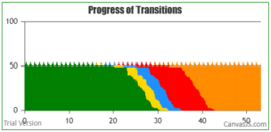

When the green count is less than 10, the red count is also less than 10, where the line is. If the system is geared to reacting to a case, the hidden cases may be more than 50% of the population.

***The Emergency Department (ED) and Community Pool (U7)***

In these trials, instead of having the same persons in the ED as permanent residents (unrealistic) as compared to Long Term Care, the population file has 50 unique persons in ED every day, leaving at midnight, with new groups arriving at midnight.

There is no constraint in the population files that these need be continuous or contiguous, and after trial and error, some spacing between groups of 50 was created, so that infected transients from the BlueBell family cohort could happen upon an ED wit 50 persons.

The spacing sets 7 groups of 50, on days 14, 21, 25, 29, 33, 38 and 44. However, the volunteers and health care workers (HCW) are agents 47 and 50 for volunteers and 54,57,65 and 69 for HCW. The first are present from 7 to 11 for 4 hours and the HCW from 7 to 1700 for 10 hrs daily.

In this simulation, the transients go daily. In U2, the Inflation index is set to 3 (high) so that in the short time the 50 are exposed to the 6 transients, there is some chance for there to be transmission. This parameter can certainly be changed.

At the end of 24 hours, the 50-person ED group are sent to Universe 7, which we call “Community Pool”, with a Mingle Factor of 1.5, and no Inflation modification is made. We decided that if we were going to make these 50 leave, we may as well see what happens to them in the “Community Pool” space.

In this trial, we terminated at a situation in which no further infections at HOME, BlueBell or LTC can occur. If there are no infectives in those Universes, they cannot, even if there were susceptibles remaining among the BlueBell cohort and families, be infected by new arrivals in ED or by any contagion activity in Universe 7, which is closed to the rest of the system.

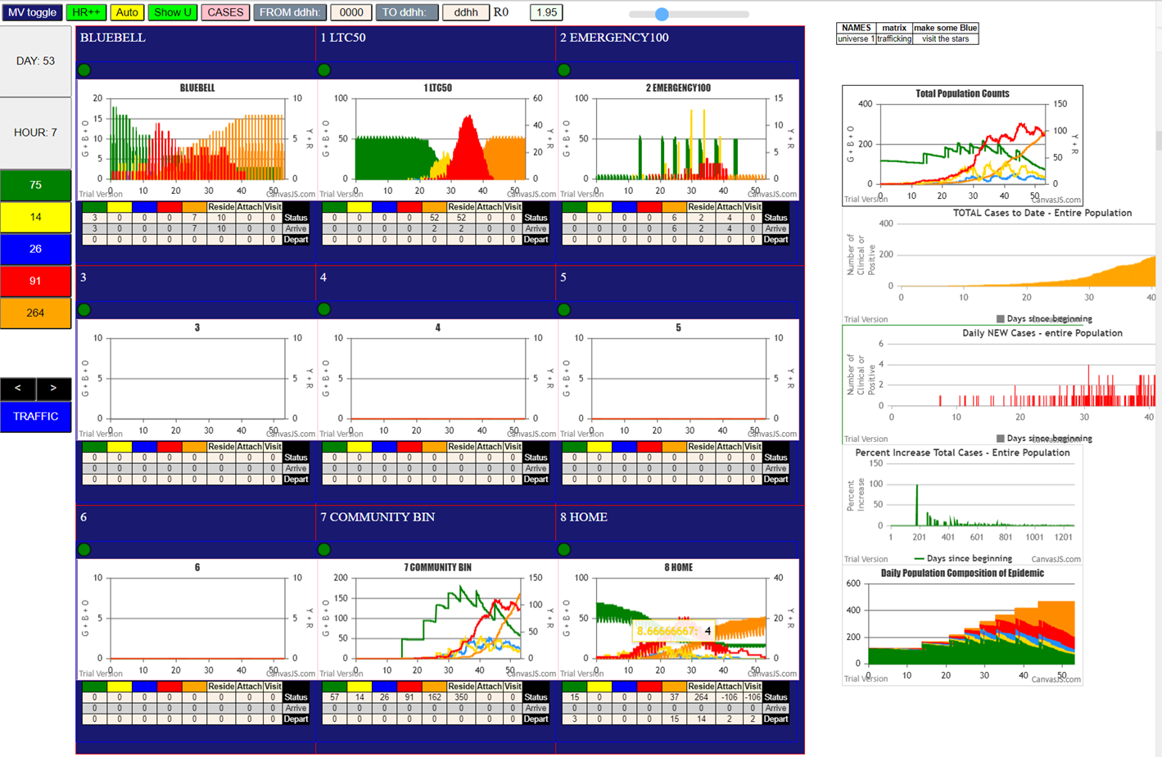

The tables below the charts for BlueBell, LTC, ED and HOME (U0, U1, U2 and U8) show zero for yellow, blue and red. Activity is still going on in U7. The chart for U7 (the Community Pool) shows a saw-tooth pattern of increments of 50 susceptible (green) at staggered days. The downslopes from them show that the count of susceptibles decline as infections proceed within this closed space. Indeed, at the point of termination (Day 53 Hr 7 = gen 1279) we see the following in U7:

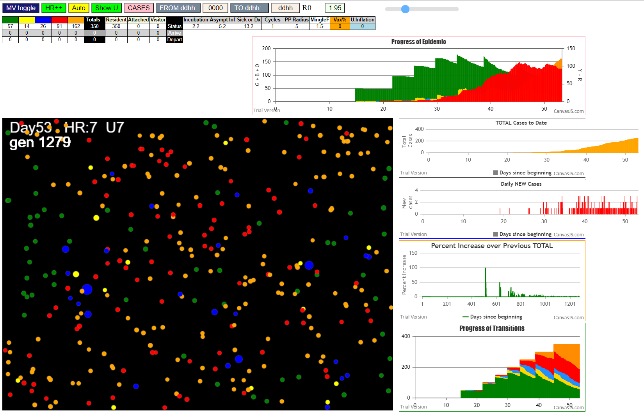

There are 350 agents here (the black entry, first line of tables on left), and they are in various states of green, yellow, blue, red and orange (the table reads: 57G, 14Y, 25B, 91R, 162 Orange). From the console.log, the first infection in U2 (the important one) was at gen 343, approximately D14.



In the gen from 919 to 927, 8 infections took place; from 799 to 808, another 13; from 703 to 715, there were 13, etc. as shown:



This shows that in the 10 hour period when transients 47,69, 54, 57,69 are present, there can be, at each hour, one or more transmissions. Furthermore, the stochastic viral load in transmissions permit some transmissions to occur within the average incubation period of 2.2 days, so that the infectiousness is not slavishly tied to days, but to viral load, with the color of agent marking the average state change.

Although we may be too aggressive in having six transients go to ED, we can compensate by asking when each one became infective, so that the likelihood of one of them being the only transient can be seen.

The following table relates the infection date of each of the transients to ED, their infective period (starting 2 days after infection, lasting 11 days after pres-symptomatic infectious), and the overlap with the days at which the ED50 groups are present.



This shows that if agent 50 is the only one that is designated, it would in this run be infected on day 10.8, and the ED days of 14 and 21 would encounter agent 50 being infective, with a possibility of transmitting to one of the 50.

This table shows that 25,30,33 covers five of the infection dates for agents 47 to 69. However, this is just a spread of 17.3 to 29.2 days. In theory, if we assign one person only to be a transient, and that person became infected in the span day 17.3 to 29.2, we would have a window of transmission from one of 25, 30 and 33 for ED50 placements.

Similarly, if we had to choose just 2 days to place the ED50 groups, day 21 and day 33 would cover all of the infection dates for the agents. So choosing agents 47 and 57, and days 21 and days 33 would remove most of the redundancy in this trial.

However, with stochasticity, we cannot be certain, as we also cannot be certain IRL, that this same distribution would repeat, or how often it would repeat.

**OTHER TRIALS FOR CONSIDERATION OF CONSISTENCY**

We will proceed in the same order: fit to data constraints, evolution of BlueBell and family, LTC and ED.

***Fit to Data Constraints***

The summary table is shown below for 6 trials. The second column “U0+U8 by Jan8” is the statement that there were 16 cases by Jan 8. The description applies to U0 the BlueBell childcare plus U8, the HOME Universe for the family members of the BlueBell staff and kids. The next column applies only to the BlueBell facility.

The columns “U8 children” and “U8 adult” refers just to the population of members of those attending BlueBell as staff and kids.



It can be seen that Trials 1, 6 and 4 agree fairly well, but Trial 5 and 3 vary significantly. Instead of throwing them out, however, we kept them to see whether there are internal dynamics which work in a similar way, bas the parameters are the same, despite the upfront divergence.

***Evolution of BlueBell Cluster and Families at Termination***

The perspective that CovidSIMVL offers is that it is not a tool for prediction of IRL situations, but it can be used to investigate scenarios and explore their dynamics as they unfold in simulations.



These columns relate to the exemplar discussion above. For clarity, the “BB staff” refers to the number of the BlueBell staff that have been infected by Termination, and “BB kids” to the children who attend BlueBell. Similarly, “BB cc” stands for “BlueBell Childcare” and is the sum of the previous two, while “BB-fam kids” and “BB-fam adults” are those family members of the “BB cc” who do not attend BlueBell but are related through the family structure given above. The sum of these make up the “BB group” which number 70 as a population, while these numbers are the totals in each trial that have been infected till Termination.

“Last BB” is the time at which the last infection of a BB member (of the 20 staff and students) was registered, while “Last BB-Gp” is the last infection of the entire extended group of 70 was recorded. The “Ext U1” and “Ext U2” columns are the numbers of infections of the BB extended group that happened outside HOME and BlueBell, and these would be in Universe 1 Long Term Care, and U2 Emergency, in which the infected not the residents but each other.

Finally the percentages are for the BlueBell Childcare members being infected as a % of that specific population of 20, while the BB-Gp% is for the larger extended members as a percentage of their numbers, which is 70. The External Inf % is the number of such infections over the total number of person, again being 70.

It can be seen that there is close agreement between Trials 1, 6 and 4 and 2 while Trial 5 appears to be an outlier. Trials 5 and 3 are significantly reduced in the total of the associated family members being infected, both in the non-BlueBell children and in the case of Trial5, also in extended family adults. This brings the % of the BB-Gp down to 50%.

***Long Term Care Impact***

The following table compares the time of first infection and of the last infection registered for LTC members (agent IDs 70 – 119). This gives a picture of the progress of the epidemic within LTC, once it gets there. So the start time, and the duration, is together a measure of the intensity of the affected LTC. The column “inf by RED” is the count of the infections by agents in the symptomatic state, of 50 such infections.

The examination extends to the % of the infections within LTC by agents that have gone into the symptomatic part of the viral temporal model, and it can be seen that this is a low number. The implication is clear: that rapidly contagious epidemics in Covid spread by pre-symptomatic transmission



In all of these trials, the LTC residents are 100% infected by Termination, which is invoked when there are no more possible infective agents outside of Universe 7 (the Community Pool) that can infect the extended group from BlueBell. This happens in these trials above 1100 and below 1500, which is well after the last infection in LTC.

Thus, the end result is the same, and the starting date refers to the aggressiveness of the specific epidemic, as created by the parameters stochastically. From that point of view, Trial 5 and 3 have an early start at D14 and D15, but even though they also finish sooner than the others, the duration is somewhat longer.

***Emergency Department Impact***

In each trial, the same volunteer and workers (45,50,54,57,65,69) go daily to the ED (Universe 2) and on the appointed days (D14,21,25,29,33,38 and 44) 50 persons appear at the ED for 24 hours and mingle with the transients for 10 hrs for the 4 health care workers, and 4 hrs for the volunteers.

If there is a coincidence of the worker visit with the 50-person appearance, and the worker is infective, then there may be a transmission to one or more of the 50 persons, who at the end of 24 hrs go into Universe 7, the Community Pool, and can bring the contagion into that growing population. In the section above, we explored the relationship between days of transmission and the seven selected days. Earlier trials had the 7 days clustered too early, and none of the transients became infective before the appearances of the 50 were over.

Here, we explore for each Trial, the timing of the first infection that takes place in Universe 2, the ED, as well as the timing in each Trial of the candidate vectors carrying the virus into ED – agents 47,50, 54, 57, 65 and 69.

We also for each Trial found, from the console log, which of the seven intervals coincided with infections within the ED Universe 2, and how many infections there were. The results of these are tabulated below.



What we can see from this chart is that the first infections in U2 are either on D14 or D21, and what separates these are the possibilities of one of the agents that are infected early. For example, Trial 3 has 3 agents that are infected below gen-400, and Trial 5 have 4 such agents. Trial 4 has 3 agents infected below gen-400. Although Trial 1 has only one entry below 400, and still has first infection in U2 on D14, this entry is at 260, and below 300. The ones that have first infection at D21 are Trial 6 and Trial 2: the latter has none below 450, and the Trial 6 has only one agent that was infected, and that was close to the 400 mark.

The other point of examination is how many persons are infected within the U2 24-hr periods, and when they occurred, in relation to the first infection. The following table describes these data.



The first thing to note is that Day 14, Day 38 and Day 44 attract fewer infections, and other days produce larger numbers. The second is that there appears to be no relationship between early start of an infection in U2 and the production of infections that subsequently are generated in the ED.

**DISCUSSION**

Given the sketch of a Covid-19 cluster, and using the partial data as constraints, we generated a set of parameters by trial and error for CovidSIMVL which satisfied these constraints in several trials of the simulation.

Using these parameters, we then explored the dynamics of an the specific epidemic that these parameters generate in simulation.

In particular, we looked at the number of days and the extent of infection of the BlueBell Childcare staff and children, and their families. Using a restriction of movement constraint, these simulations show that the epidemic’s endpoint in BlueBell occurs about 30 days after initial index case showed symptoms. When the entire family membership was added to the children and staff, the end point occurred in about 40 days, with about 75% of the entire population infected.

The reason in these simulation trials that there are so many persons that remain susceptible is due to the interactions specified: the infections within families could only occur among its members, and so if a BlueBell child was infected but did not transmit to its members in its transmissible period, the other members will remain as susceptibles. The nature of the CovidSIMVL implementation, in which agents occupy spaces within a fixed arena makes the family constraint an virtual expansion of the space, as contact now has to occur not with anyone, but only 3 of the entire population.

Nevertheless, the parameters were established to produce the data constraints for family cases, so we know that the family members do get infected, as indeed they do in the trials. However, eventually the simulation system can no longer generate effective transmitters into the HOME population.

This is not true for the exemplar Long Term Care and Emergency populations. In the first, we have a resident permanent population that does not move, so that daily workers from the BlueBell-family population will always be able to transmit to them. Once established, the epidemic carries on.

The Emergency Department extension was set up slightly differently, with a unique population of 50 appearing every day. The simulation included 6 persons who go to the ED daily.

It is only necessary for one transmission to occur in the ED to the population of 50 for the Community Pool to which these persons go at the end of 24 hours to be at risk. Once established, the contagion spreads as rapidly as the parameters allow.

The time to first infection into LTC in these trials, using the parameters satisfying the data constraints, is about 20 days from T0 of the index case. The time to first infection into the ED, with effective transference into U7 the Community Pool, is 14 days as a worst case, from T0 of the index case.

In the IRL cluster, 16 cases were found on January 18, at T=16D. This chart from Trial 1 shows the growth of contagious population (in Red) of the BlueBell extended HOME Universe. By Day 20, about 25 persons are contagious.

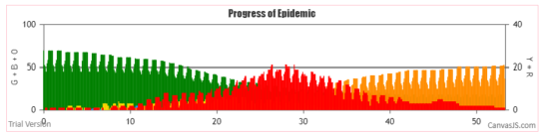

We need next to repeat these simulations scenarios with isolation and contact tracing and testing creating quarantine, all to reduce the number of days of transmissibility. In the stochastic model of CovidSIMVL, this decreases the likelihood of contact, hence of the continuation of the chains of transmission. These results will appear in the repeated simulations, and show the potential earlier self-termination.

However, the stark result from this case study and simulation is that there are many possible paths for an infection to be transmitted from a localized cluster into vulnerable or super-spreading populations, and time is not our friend, nor is the major role that pre-symptomatic transmission has been shown here.